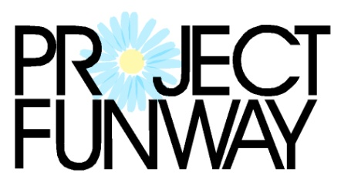 benefit for 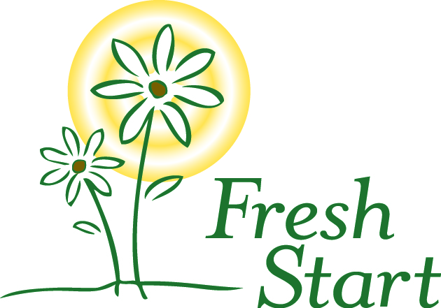

CONTEST RULES and INFORMATION

Project Funway is a design competition using the theme of transformation, to emphasize the transformation of women’s lives that is Fresh Start’s mission.

Designers are to design and create an original garment. The materials used for the garment must be clothing that is purchased from local thrift stores, such as The Daisy at Fresh Start. Thrift store clothing may be used in any way, including completely deconstructed. The clothing purchased must be transformed into an entirely different, unique garment. Designers may use other recycled materials if they contact Fresh Start in advance to discuss this. The entry must include a full outfit, which may include more than one garment (i.e. pants and a top). Each designer may enter two outfits maximum. Designers may work individually or in pairs. Designers must provide their own runway models.

Designers must enter by Friday September 15, 2017 and inform Fresh Start of the number of outfits he or she plans to enter in the show. Designers must submit a “before” photo of the clothing used to create the designs and also an “after” photo. Both are to be submitted to Fresh Start by Wednesday October 4, 2017. There is a $15 entry fee. A green room will be available to designers and models.

There will be two sets of contest winners. One will be selected by a panel of judges. The other set will be those who receive the most votes from the event guests. Each guest will receive one paper vote to put in the container for their favorite design. Additional votes may be purchased as well. The winner in each category will receive recognition and a prize.

The runway show will be during the event on Friday, October 13, 2017 at the Cornhusker Marriott. Designers and model need to arrive by 4:30. Designers and models do not need to purchase tickets. All others in attendance need tickets. Event tickets are $40 each for regular tickets or $60 for VIP tickets. A green room will be available for designers and their models and is where people may prepare for the runway show. Two sets of winners will be selected: one by a panel of judges and one by the event guests. Please refer to the contest rules for additional information. Please note that video and photography will be taken throughout the event. Please discuss any concerns about this with Fresh Start in advance.

Proceeds will benefit Fresh Start, a transitional shelter and goals program for women. Fresh Start helps women change their lives and move out of homelessness by identifying and utilizing their strengths to overcome barriers to self sufficiency.

For more information, please email monicaz@freshstarthome.org or call Fresh Start at 402-475-7777. Photos of past events are on the Fresh Start Home Facebook page. More information about the event and the entry form is available at www.FreshStartHome.org

Project Funway: Design. Transform. Overcome.

