March 2017

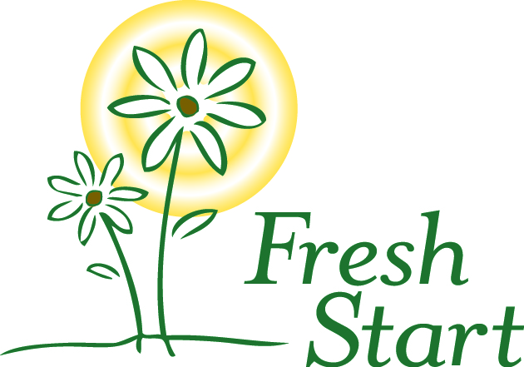

***A home where women can grow***

6433 Havelock Avenue  
Lincoln NE 68507

(402)475-7777

[www.FreshStartHome.org](http://www.FreshStartHome.org)

**2017 Board of Directors**  
Lina Bostwick, President

Bryan College of Health Sciences

Cynthia Peterson, Past President  
Community Volunteer

Kari Krier, Vice President

Community Volunteer

Liz Gebhart, Secretary

DHHS

Nick Ludwig, Treasurer  
Union Bank & Trust

Chad Bennett  
IBM

Olivia Bond  
UNL MBA student

Christine Dahl  
Kohll’s Pharmacy

Nicole Gohring

UNL

Emily Green  
DHHS

Tari Miller

DHHS

Ann Kontor

City of Lincoln, Parks and Rec

Michael Reinmiller

UNL

Denise Robeson  
Community Volunteer

Chris Peterson  
Wolfe, Snowden, Hurd, Luers, & Ahl, LLP

Krista Vogel

Hurrdat

Bub Windle

Muellar Roback LLC

Susan Wortmann  
Nebraska Wesleyan University

*Please remember Fresh Start in your charitable giving and estate planning. Fresh Start is a 501(c)(3) organization and contributions are tax deductible.*

Fresh Start is proud to partner with the   
cid:image007.jpg@01CAAFF2.4F51AE60

Dear Community Partner,

Fresh Start is hosting a mini-golf tournament on Saturday June 17, 2017 at Adventure Golf. We invite you to support this event by becoming an event sponsor. **All proceeds will benefit Fresh Start and help to provide the food, shelter and case management offered to women who are homeless in the Lincoln community**. Fresh Start is a non-profit transitional housing program offering safe housing, skill development, and supportive services.

There are *many benefits* for you as a sponsor. Marketing and donation opportunities for your business may include:

* Acknowledgement in the event program and signage at the event
* Acknowledgement in the Fresh Start newsletter (mailed to 2,000+)
* Shout outs on our Facebook and Twitter pages (950+ “likes”)
* As a nonprofit 501(c)(3) organization, donations to Fresh Start are tax deductible.

There are *several options* for businesses to participate, including:

* + Hole in One: $1,000 (includes 2 teams of 4 + extra acknowledgement)
  + Eagle: $500 (includes 1 team of 4 + extra acknowledgement)
  + Birdie: $250 (includes 2 complimentary entries)
  + Hole Sponsor: $100 (includes a sign at that hole)

Businesses also may donate items for the raffle, for golf prizes, and for the meal that will be provided to the golfers.

Sponsors at higher levels will receive additional acknowledgement for their contribution, such as your logo on our website. Event sponsors will be listed on the poster and in press releases if sponsorship is confirmed by April 15, 2017.

Fresh Start’s services are even more needed and we continue to have a wait list for our shelter. We hope that you will support this event, and our efforts to empower homeless women. **Please contact Audrey at Fresh Start at (402) 475-7777 or audreyb@freshstarthome.org** if you have any questions and to determine your sponsorship level. To register for the event, go to FreshStartHome.org. Thank you.

Sincerely,



Development Coordinator