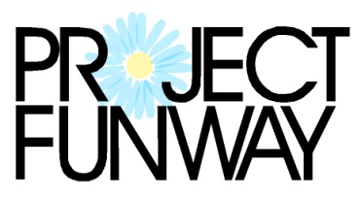 benefit for

2021 Designer Entry Form

Designer Information (please print or type)
Name
Address
City
State
ZIP Code
Telephone
E-Mail
Number of complete outfits to enter:
Name of Design (if named)
Description of Design:
This will be used for the program and should be short (approx. 2-3 sentences)
Model’s Name:

Make-up Artist: Yes󠆵󠆵 No 󠆵󠆵 | Hair Salon: Yes 󠆵󠆵 No 󠆵󠆵

Designer Signature:

Designers must enter by Friday October 1, 2021. There is a $15 entry fee to participate. Designers are to submit “before” pictures of the garments that were purchased and are being transformed. An “after” picture also is to be submitted. Photos need to be received by Friday October 22, 2021. An electronic version of the photo is preferred, but a 4 x 6 inches photo could be mailed. If photos or the design description are not received by the designated time, “not available” will be listed and no description offered during the event. Please note that there will be photography and video taken during the event. Entering the competition implies consent to and authorization of the use of your likeness to be used in printed and/or audiovisual material by Project Funway, Fresh Start, and the organizers or sponsors of the event.

The event is on Friday November 12, 2021 at the Cornhusker Marriott. Designers and models need to arrive by 4:30 to practice the runway show. Doors open at 6:30PM. Tickets for non contestants are $50 and include one “vote” in the competition and VIP $75. Day of event tickets are increased to $60. Designers and models do not need to purchase a ticket. All others will need to purchase a ticket. Student tickets are available at a reduced price.
Please contact Monica at Fresh Start if you are interested in being a designer, an event sponsor, donating an item for the silent auction or if you would like to help plan the event. More information is also available on our website FreshStartHome.org and on our Facebook page. Proceeds from the event benefit Fresh Start, a transitional shelter and goals program that assists women who are experiencing homelessness by changing their lives and becoming self sufficient.
Monica Zinke monicaz@freshstarthome.org or 402-475-7777
Fresh Start 6433 Havelock Avenue Lincoln, NE 68507

