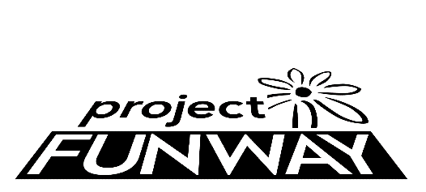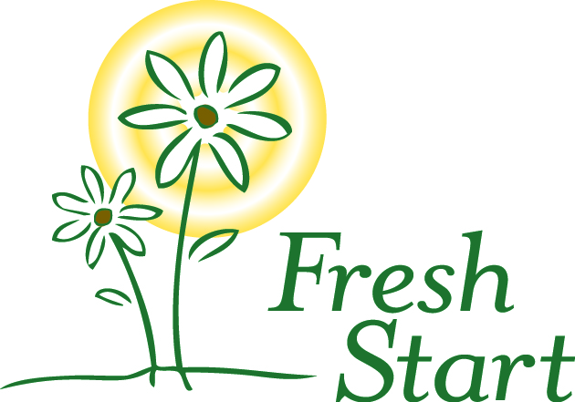

CONTEST RULES and INFORMATION

Project Funway is a design competition using the theme of transformation, to emphasize the transformation of women’s lives that is Fresh Start’s mission.

Designers are to design and create an original garment. The materials used for the garment must be clothing that is purchased from local thrift stores, such as The Daisy at Fresh Start. Thrift store clothing may be used in any way, including completely deconstructed. The clothing purchased must be transformed into an entirely different, unique garment. Designers may use other recycled materials if they contact Fresh Start in advance to discuss this. The entry must include a full outfit, which may include more than one garment (i.e. pants and a top). Each designer may enter two outfits maximum. Designers may work individually or in pairs. Designers must provide their own runway models.

Designers must enter by October 1, 2024 and inform Fresh Start of the number of outfits she/he/they plans to enter in the show. Designers must submit a “before” photo of the clothing used to create the designs and also an “after” photo. Both are to be submitted to Fresh Start by October 25, 2023. Designers also may submit a 2 sentence description. There is a $25 entry fee. This is waived if the designer is in a UNL class that is participating in the event. (Contact Dr. Starkey for details.) If photos or the design description are not received by the designated time, “not available” will be listed and no description offered during the event.

The runway show will be during the event on Friday, November 1, 2024 at the Cornhusker Marriott. Designers and model need to arrive by 4:30 for a practice walk of the show. A green room will be available for designers and their models and is where people may prepare for the runway show. There will be two sets of winners. One will be selected by a panel of judges. The other set will be those who receive the most votes from the event guests. Votes may be purchased, and proceeds support Fresh Start services. The winners in each category will receive a prize.

Designers and models do not need to purchase tickets. All others in attendance need tickets. Event tickets are $65 ($75 days of show) each for regular tickets or $85 for VIP tickets ($100 day of show). Students may purchase tickets at a reduced rate of $25.

Please note that video and photography will be taken throughout the event, and will be used on social media, the Fresh Start website and in publications. Please discuss any concerns about this with Fresh Start in advance.

Proceeds will benefit Fresh Start, a transitional shelter and goals program for women. Fresh Start helps women change their lives and move out of homelessness by identifying and using their strengths to overcome barriers to self-sufficiency.

Contact Monica monicaz@freshstarthome.org or call Fresh Start at 402-475-7777 if you are interested in being a designer, an event sponsor, donating an item for the silent auction or if you would like to help plan the event. More information is also available on our website. FreshStartHome.org and on our Facebook page. Photos of past events are on the Fresh Start Home Facebook page.

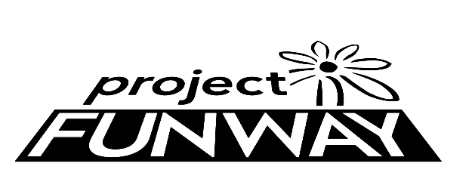 benefit for

2024 Designer Entry Form

Designer Information (please print or type)
Name
Address
City
State
ZIP Code
Telephone
E-Mail
Number of complete outfits to enter:
Name of Design (if named)
Short Description of Design:
(approx. 2-3 sentences)
Model’s Name:

Hair Salon: Yes 󠆵󠆵 No 󠆵

Entry Due Date: October 1, 2024
Photo/Images Due Date: October 25, 2024
Event Date: Friday November 15, 2024 Arrival Time: 4:00-4:30pm Location: Cornhusker Marriott
Designers and models need to arrive by 4:30pm to practice the runway show.
Please note that there will be photography and video taken during the event. There is no compensation for participation in the event or for use of images/video. Entering the competition implies consent to and authorization of the use of your likeness to be used in printed and/or audiovisual material by Project Funway, Fresh Start, and the organizers or sponsors of the event.
Please contact Monica at Fresh Start if you have any questions monicaz@freshstarthome.org or 402-475-7777. More information is also available on our website FreshStartHome.org and on our Facebook page. Proceeds from the event benefit Fresh Start, a transitional shelter and goals program that empowers women experiencing homelessness to change their lives.
Yes, I have read the contest rules and information form.
Designer Signature:
(Parent or guardian signature if under age 18)

