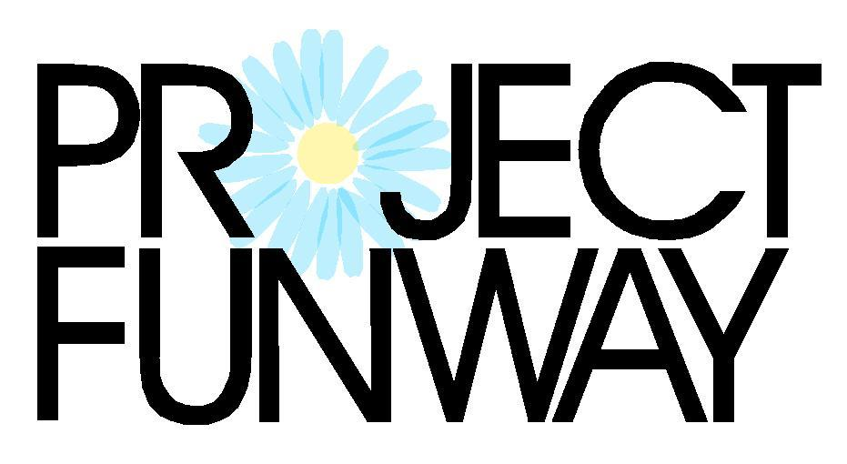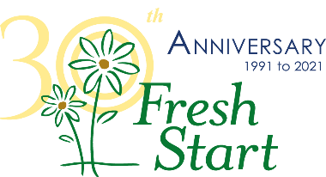
Dear Friends of Fresh Start:

Fresh Start is excited to announce the return of Project Funway, a fashion design competition and runway show where UNL students and local designers compete by creating one of a kind, original outfits. The event is scheduled for Friday, November 12, 2021 at the Cornhusker Marriott, and also includes a silent auction and hors d’oeuvres. Advance tickets are $50 each and VIP tickets are $75. Day of event general admission tickets are $60.

We invite you to support Project Funway by becoming an event sponsor. All proceeds will benefit Fresh Start and help support the vital services provided to our female residents such as food, clothing, shelter, and case management. Fresh Start is a non-profit goal-oriented housing program for women experiencing homelessness, offering safe housing, skill development, and supportive services.

Since you know what works best for your company and individuals, you may select which type of additional acknowledgement you prefer:
- Name or company logo on sponsor signage at the event.
- Acknowledgement in the Fresh Start newsletter (mailed to 2,000+)
- Shout out on our Facebook and Twitter page (1,400+ “likes”)
There are several options for businesses to participate. Sponsorship levels include:
- Trendsetter $500: A listing in the program and slideshow, 1 additional acknowledgement, and 2 tickets to the event
- Fashion Idol $1,000: The benefits of first level, plus 3 additional acknowledgements, your logo in the event program and on the VIP sponsor signage, and 6 total tickets
- Backstage Pass $2,500: The benefits of other levels, plus an additional acknowledgement, extra recognition in Fresh Start mailings, on all sponsor signage, logo on the Fresh Start website, and 8 total tickets
- Runway Sponsor $4,500: The benefits of other levels, plus additional recognition at the event, recognition in The Daisy thrift boutique, and 10 total tickets to the event

These are not the only opportunities to be an important part of our event. Please consider donating or sponsoring an auction item. This could be a basket of items, a date night out package, or business services. We would love to partner with you! Auction donors will be listed in the event program and slideshow.

In the past few years, Fresh Start’s services have been in higher demand and we continue to have a waitlist for our shelter. We hope that you will join us, and our efforts to empower women who are homeless. Please contact Audrey at Fresh Start at (402) 475-7777 or by email at audreyb@freshstarthome.org if you have any questions or would like to discuss your sponsorship level. Event ticket registration will be available starting in June on our website, FreshStartHome.org. Thank you!

Sincerely,
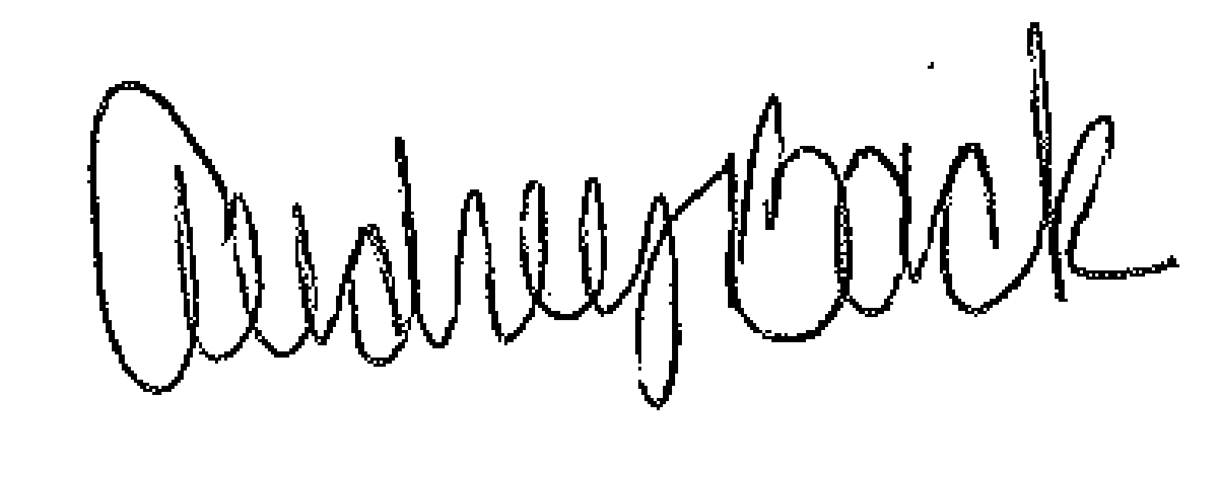
Audrey Back
Development Coordinator

