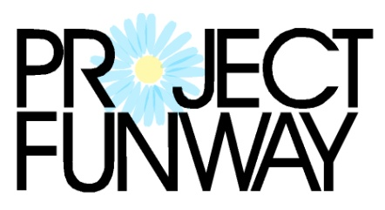

CONTEST RULES and INFORMATION

Project Funway is a design competition using the theme of transformation, to emphasize the transformation of women’s lives that is Fresh Start’s mission.

Designers are to design and create an original garment. The materials used for the garment must be clothing that is purchased from local thrift stores, such as The Daisy at Fresh Start. Thrift store clothing may be used in any way, including completely deconstructed. The clothing purchased must be transformed into an entirely different, unique garment. Designers may use other recycled materials if they contact Fresh Start in advance to discuss this. The entry must include a full outfit, which may include more than one garment (i.e. pants and a top). Each designer may enter two outfits maximum. Designers may work individually or in pairs. Designers must provide their own runway models.

Designers must enter by Friday October 5, 2018 and inform Fresh Start of the number of outfits he or she plans to enter in the show. Designers must submit a “before” photo of the clothing used to create the designs and also an “after” photo. Both are to be submitted to Fresh Start by Wednesday October 24, 2018. Designers also may submit a 2 sentence description for the program, which may be edited for space as needed. There is a $15 entry fee.

The runway show will be during the event on Friday, November 2, 2018 at the Cornhusker Marriott. Designers and model need to arrive by 4:30. Designers and models do not need to purchase tickets. All others in attendance need tickets. Event tickets are $40 each for regular tickets or $60 for VIP tickets. Students may purchase tickets at a reduced rate. A green room will be available for designers and their models and is where people may prepare for the runway show. There will be two sets of winners. One will be selected by a panel of judges. The other set will be those who receive the most votes from the event guests. Each guest will receive one paper vote to put in the container for their favorite design. Additional votes may be purchased as well. The winners in each category will receive recognition and a prize.

Please note that video and photography will be taken throughout the event, and will be used on social media, the Fresh Start website and in publications. Please discuss any concerns about this with Fresh Start in advance.

Proceeds will benefit Fresh Start, a transitional shelter and goals program for women. Fresh Start helps women change their lives and move out of homelessness by identifying and utilizing their strengths to overcome barriers to self sufficiency.

For more information, please email audreyb@freshstarthome.org or call Fresh Start at 402-475-7777. Photos of past events are on the Fresh Start Home Facebook page. More information about the event and the entry form is available at www.FreshStartHome.org

