March 2018

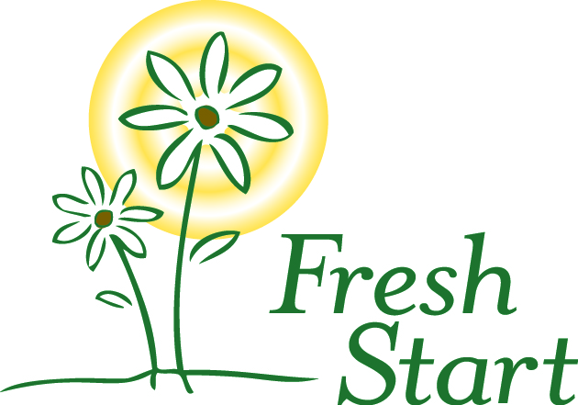

***A home where women can grow***

6433 Havelock Avenue  
Lincoln NE 68507

(402)475-7777

[www.FreshStartHome.org](http://www.FreshStartHome.org)

**2018 Board of Directors**  
Liz Gebhart, President

DHHS

Cynthia Peterson, Past President  
Community Volunteer

Kari Schmitz, Vice President

Community Volunteer

Nicole Gohring, Secretary

DHHS

Nick Ludwig, Treasurer  
Union Bank & Trust

Jenn Beebe  
Relish Catering

Olivia Bond  
UNL MBA student

Mindi Chollet  
Telesis, Inc

Lora Curry  
Community Volunteer

Emily Green  
DHHS

Michelle Keogh  
Hampton Enterprises

Tari Miller

DHHS

Chris Peterson  
Wolfe, Snowden, Hurd, Luers, & Ahl, LLP

Michael Reinmiller

UNL

Denise Robeson  
Community Volunteer

Krista Vogel

Spreetail

Bub Windle

Muellar Roback LLC

Susan Wortmann  
Nebraska Wesleyan University

*Please remember Fresh Start in your charitable giving and estate planning. Fresh Start is a 501(c)(3) organization and contributions are tax deductible.*

Fresh Start is proud to partner with the

cid:image007.jpg@01CAAFF2.4F51AE60

Dear Community Partner,

Fresh Start is hosting a mini-golf tournament on Saturday June 09, 2018 at Adventure Golf. We invite you to support this event by becoming an event sponsor. **All proceeds will benefit Fresh Start and help to provide the food, shelter and case management offered to women who are homeless in the Lincoln community**. Fresh Start is a non-profit transitional housing program offering safe housing, skill development, and supportive services.

This event has grown in recent years, and the last two years have sold out for attendance! There are *many benefits* for you as a sponsor. Marketing and donation opportunities for your business may include:

* Acknowledgement and signage at the event
* Acknowledgement in the Fresh Start newsletter (mailed to 2,000+)
* Shout outs on our Facebook and Twitter pages (1,400+ “likes”)
* As a nonprofit 501(c)(3) organization, donations to Fresh Start are tax deductible.

This year, there are even more opportunities to be involved. We are holding two events, one in the morning and one in the afternoon! Both will feature mini golf, food and prizes.

There are *several options* for businesses to participate, from $150 Hole Sponsorships to full year event sponsorships of $5,000. Information about all of the options are detailed on the reverse. Sponsors and donors at higher levels will receive additional acknowledgement for their contribution, such as your logo on our website. Event sponsors will be listed on the poster and in press releases if sponsorship is confirmed by April 12, 2018.

Businesses also may donate in kind items, such as items for the raffle, prizes for golfing and team challenges, and food and beverages for the meal that will be provided to the golfers.

Fresh Start’s services are even more needed and we continue to have a wait list for our shelter. We hope that you will support this event, and our efforts to empower women who are homeless. **Please contact us by phone at Fresh Start at (402) 475-7777 or by email at monicaz@freshstarthome.org or audreyb@freshstarthome.org** if you have any questions and to determine your sponsorship level. To register for the event, go to FreshStartHome.org. Thank you.

Sincerely,



Development Coordinator