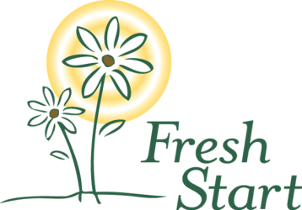
2018 Fresh Start Mini-Golf Tournament
Saturday, June 09, 2018
Adventure Golf, 5901 S 56th St, Lincoln, NE 68516

Team Fundraising Challenge!
Teams are challenged to raise an additional $180 (or more!) for Fresh Start ($10 per hole). All teams that meet this fundraising goal will be entered to win a prize. Additional prize offered for the team that raises the most! Tax receipts will be mailed to all donors where complete addresses are provided.

Team Name: ______________________________________________

Name: | Address: | Phone: | Email | Total Amount: | Add to mailing list (y or n)
Example Smith | 6433 Havelock, 68507 | 402-475-7777 | FreshStart@example.com | $10.00 | Y
Bring the form(s), along with the donations, to turn in at the event registration table. Saturday, June 09, 2018 9:00am
Fresh Start is a transitional shelter for homeless women. Fresh Start, Inc. is a charitable corporation that is organized under Section 501(c)(3) of the Internal Revenue Code. Contributions made to Fresh Start are deductible for tax purposes. No goods or services were provided in exchange for this donation.

